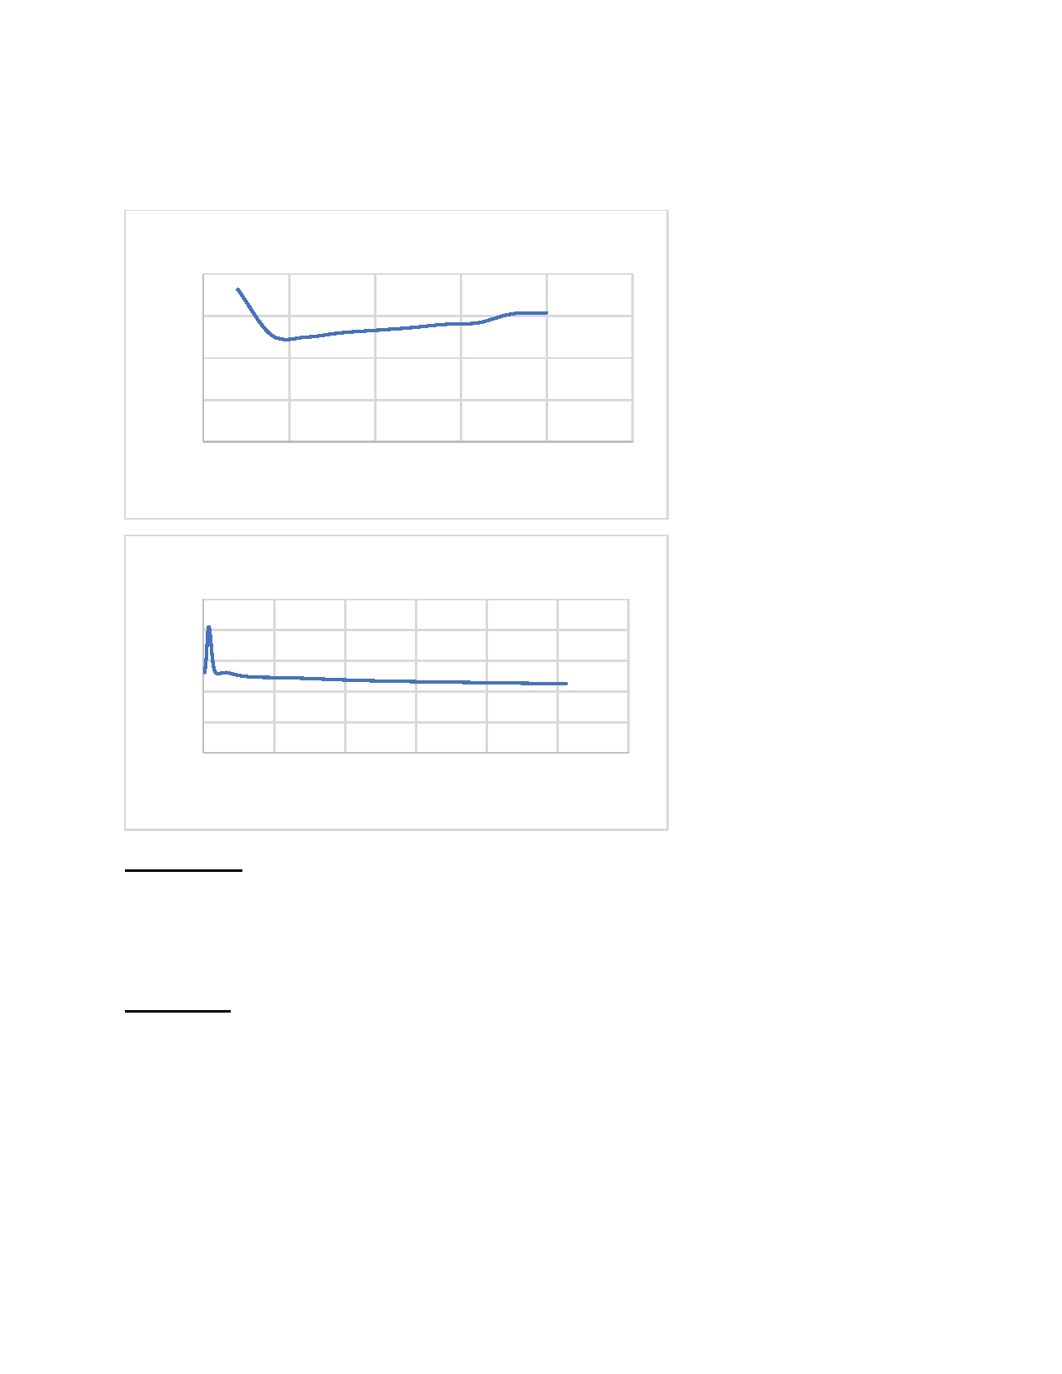
PA4 REPORT: THREADING AND SYNCHRONIZATION
Time (s)
Time (s)

DATA REQUESTS:

Number of Threads vs Time
20

15

10

5

0
Muhammad Taha Haqqani
CSCE 313-507

0 500 1000 1500 2000 2500

25
20 15 10
50
Number of Threads

Buffer Size vs Time

0 5000 10000 15000 20000 25000 30000
Buffer Size

Observations:

• Time taken decreases until number of threads are around 500
• Time taken increases linearly when thread count is increased beyond 500
• Time taken decreases linearly when buffer capacity is increased
Explanation:

• Increasing the number of threads causes greater context switching which has a
significant impact on performance
• Increasing the number of threads also leads to more pop calls which leads to greater
instances of underflows
• For this design, the best performance is achieved by having close to 500 threads
• Increasing the buffer capacity reduces the number of overflows and leads to better
performance

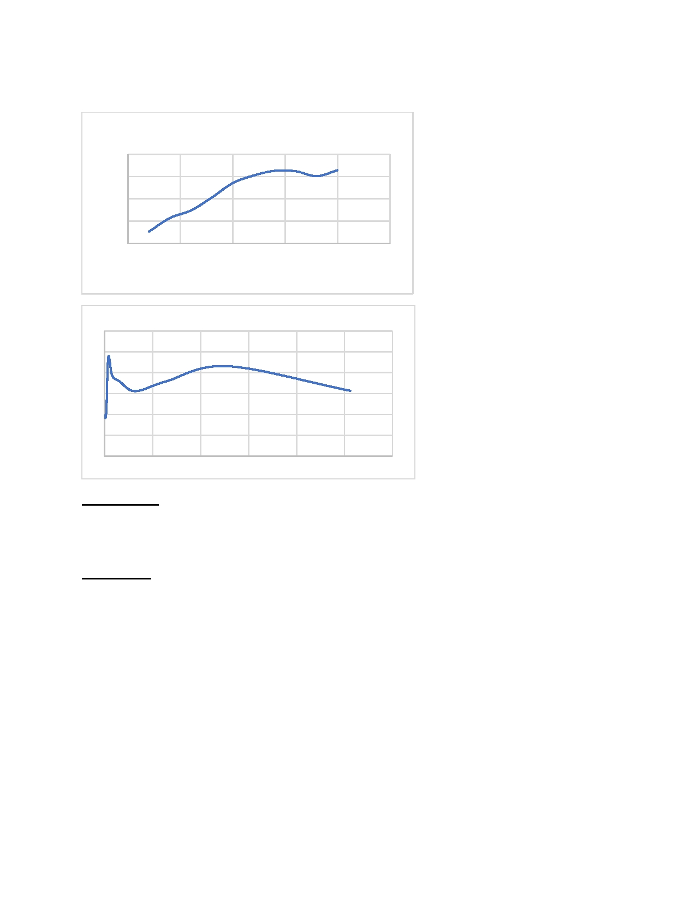
FILE REQUESTS:
Time(s)
Time (s)

Number of threads vs Time
8

6

4

2

0
0 500 1000 1500 2000 2500

30

25

20

15

10

5

0
Number of Threads

Buffer Size vs Time Taken

0 20000 40000umbe60000hreads
N r of t 80000 100000 120000

Observations:

• The time taken increases almost linearly for increasing the number of threads
• Buffer size has show varying change in the time taken
Explanation:

• Increasing the number of threads decreases the time taken because of context
switching
• The time taken is best for smaller number of threads
• Buffer size does not affect the performance since multiple threads are present

